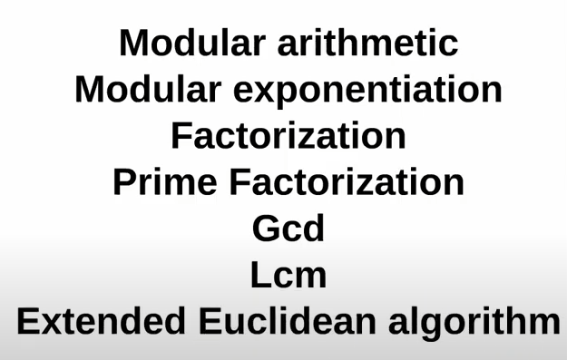


- Modular Arithmetic:
- x % y: Smallest non-negative number m such that make (x – m) is divisible (or multiple) by y.
- math equ: x % y = m or q * y + m = x
x > y: m > 0
x = y: m = 0
x < y: m = x
x = 0: m = 0
y = 0: error
- Properties:
- Cyclic >> 0123456789 % 5 = 0123401234 [0, y – 1]
- If a & b are large numbers, so their sum or product gonna be so large.
(a + b) % c = ((a % c) + (b % c)) % c
(a * b) % c = ((a % c) * (b % c)) % c
- [0, c-1] each, worst case is 2(c - 1) % c or (c-1)^2 % c

- x < 0: (x + n*y)%y, where n is smallest number that make (x + n*y) +ve. a % c = ((a % c) + n*c) % c
- (a - b) % c = ((a % c) - (b % c) + (n * c)) % c
Worst case that a % c = 0, b % c = c – 1
then the result is –(c-1) so we add n*c to make it positive.
- (a / b) % c = ((a % c) * (b ^(-1) % c)) % c

- Sum of first n numbers: n*(n + 1) / 2
- Sum of first n even numbers: n*(n + 1)
- Sum of first n odd numbers: n^2

- No. of even numbers till n : (int)(n / 2)
- No. of odd numbers till n: (int)((n + 1) / 2)

- Modular Exponentiation:
- X^n: X * X * X * …… * X (n times O(n)).
- Fast power (Binary exp.): log2(n)
n is even: X ^ n = (X^2) ^ n/2
n is odd: X^n = (X)*(X)^ n – 1 = (X) * (X^2)^ (n - 1)/2
Code:

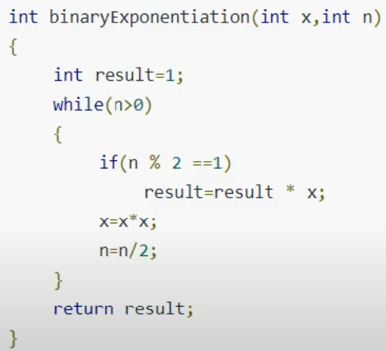

- Mod of high powers
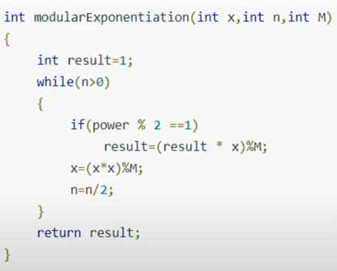

If u use long long, then (x * x) gonna be so large, then use (x * x) % m = ((x % m) * (x % m)) % m

- Factorization: find factors
- A Factor is a number that divides into another number exactly and without leaving a remainder.
- Any number than achieve m % factor = 0
- i <= sqrt(n) but O(log(n)), so use i * i < n O(1)
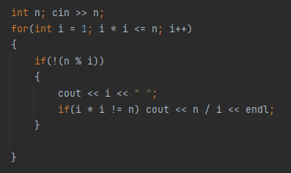
- Code:

- Prime Factorization
- Prime number: a number with two factors only 1 & n.
- 2, 3, 5, 7, 11, …
- Every integer greater than 1 can be written as the product of prime numbers.
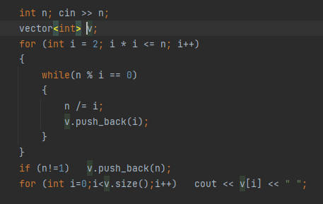
- Prime factorization code:

- Greatest common divisor (GCD)
- Greatest common factor of two numbers.
- Simple implementation using for loop: O(min(a, b))
- Another implementation: product of the common prime factors.
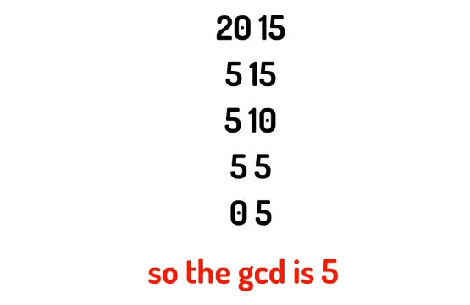
- Euclidean Algorithm:

- GCD(a, b) = GCD(b, a % b) till b = 0 then result is a.

- Least Common Multiple (GCD)
- Least number that a & b are two factors of it.
- LCM(a, b) = c, where c % a == 0 & c & b == 0.
- LCM(1260, 7350) = ??
1260 = 2*2*3*3*5*5*7, 7350 = 2*3*5*5*7*7
LCM(1260, 7350) = 2*2 * 3*3 * 5*5 * 7*7 = 44100
- بنضرب ف الأكثر تكرارا لكل رقم
- LCM(a, b) = a * b / GCD(a, b)
- GCD هو ضرب الأقل تكرارا
- GCD(a, b) * LCM(a, b) = a * b

- Sum of all numbers between two numbers (inclusive):
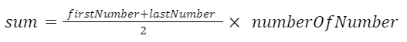

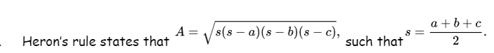
- Area of a triangle:

- x + y > z
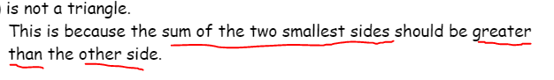
- x + y = z (degenerate triangle)

- How many distinct triangles?
n * (n + 2) * (2*n + 1) / 8

- The k-th positive integer that is not divisible by n:
K + ( (k - 1) / (n – 1) )

- XOR:
n ^ n = 0
n ^ 0 = n
1 ^ n = n + 1

- number of integers divisible by both a & b in the range 1 to n:
n / lcm(a, b)

- MEX(a1, a2, a3, …, an):
the smallest non-negative integer that is not present in the set.

